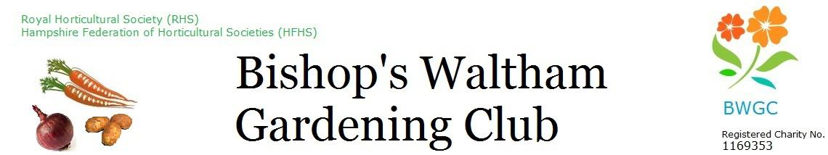
Open Annual Show Trophy Winners 2025
No. | Trophy name | Awarded for | Awarded to
1 | Viscount Cunningham Challenge Cup | Open Vegetables | Larry Mabey
2 | Joan Powell Challenge Cup | Novice Vegetables | Steve Chiltern
3 | Marsh Trophy (Roy Marsh) | Best Shallots in section  A and B | Larry Mabey
4 | Col. P. D. Powell Challenge Trophy | Best Exhibit in Section  A and B | Larry Mabey
5 | James Duke & Son Challenge Rose Bowl | Open floral | Wendy New/ Ann Magrath
6 | Woodlea Nursery Challenge Trophy | Novice floral | Nicole Jones
7 | Capt. Colville RN Challenge Trophy | Best Exhibit in Section C and D | Dominique Fornasiero
8 | Banksian Medal (RHS) | Most prize money in Section A and C | Larry Mabey
9 | The Pearson Trophy (Estate Agents) -Sponsor | Most Fragrant Rose | Glenis Hayes
10 | Bath Travel Challenge Cup | Best Exhibit in Section G (Cookery) | Kris Bird
11 | Mr. W. F. Fowle Challenge Trophy | Best specimen rose exhibit | Not awarded
12 | Bishop Cup (Mrs. G. Eustace) | Best sweet pea exhibit | Catherine Best
13 | Sunshine Salver (Moira Dean) | Best container | Ann Magrath
14 | Gould Hillcrest Trophy (Barbara Gould) | Best preserve (Section F) | Jos Creese
15 | B W Chamber of Trade Challenge Salver | Most Points for Preserves | Bev Rutter
16 | Marjorie Stainer Trophy  (Gill Stainer and Judy Marsh) | Most points for cookery | Judy Marsh
17 | The Spoon Trophy- (BWGC) | Best Men's Cake | Ian Newton
18 | Bobby Flook Challenge Cup | Best floral arrangement | Brenda Cogswell
19
20 | Ken Baldock Challenge Trophy | Best painting | Kris Bird
21 | Keith Fry Coppice Hill Trophy | Best photograph | Brenda Cogswell
22 | Mr. A. Quiney Challenge Shield | Best ''I made it myself' exhibit | Alan Coley
23 | Julie Farmer Challenge Trophy | Most points for crafts (Section J) | B Cogswell/ J Coley

